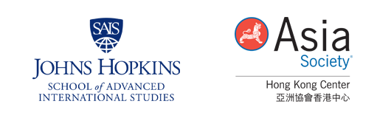
MEDIA REPLY FORM

Foresight and Regional Strategies Series
Digital Challenges to the International System

Date: Thursday, May 31, 2018
Registration: 4:30pm
Forum: 5:00pm (Please see full agenda on media advisory)
Reception: 7:15pm
End: 8:00pm
Venue: Asia Society Hong Kong Center
9 Justice Drive, Admiralty, Hong Kong

I ___________________________________ will / will not attend the above-mentioned presentation.
Media outlet | :
Media type | : | Print / On-line / TV / Radio / Others (please specify)
Reporter name | :
# of people attending | :
Tel | :
Email | :

Optional: Request for one-on-one interview
Speakers’ names  (please specify) | :
Interview format | : | Face-to-face / Telephone / On-site video taking / Others (please specify)
Photo-taking required | : | Yes / No
Expected interview duration | :
Expected publication date | :

Please email completed form to mediahk@asiasociety.org to register attendance. Walk-in request will not be accepted.

For more information, please contact:
External Affairs, Asia Society Hong Kong Center
Barbara Tong +852 2103 9513, btong@asiasociety.org
May Tam +852 2103 9559, mtam@asiasociety.org
Email: mediahk@asiasociety.org

